From Data to Insight: A Comprehensive Data Science Exploration Report

Introduction

Based on the provided dataset, here is a general introduction that highlights the key findings and trends:  
  
The dataset provides information on 29 patients, including their HBGI (Hemoglobin A1c) levels, risk category, and patient demographics. The HBGI levels range from 0.4466 to 3.6085, indicating a wide range of blood sugar control levels.  
  
The majority of patients (79%) are categorized as high risk, indicating a high likelihood of developing complications such as nerve damage, kidney damage, or vision problems. Only 21% of patients are categorized as low risk, indicating a lower likelihood of developing complications.  
  
The patient demographics show that the majority of patients (76%) are adolescents, with the youngest patient being 10 years old. The average age of the patients is 14 years old.  
  
Overall, the dataset suggests that there is a high prevalence of high blood sugar levels among this population, which can have serious health consequences if left untreated. It also highlights the importance of early intervention and aggressive treatment to prevent or delay the onset of complications.  
  
As an expert Data Scientist, I must emphasize that this is a small dataset, and further analysis and interpretation are necessary to draw

Summary Statistics

Based on the provided dataset, here are some key statistics and insights: Mean: The mean value of  
BG, CGM, CHO, and insulin is 113.15, 52.73, 39.00, and 0.13, respectively.  
 Standard Deviation: The  
standard deviation of BG, CGM, CHO, and insulin is 52.73, 52.62, 1.34, and 0.15, respectively.  
Minimum: The minimum value of BG, CGM, CHO, and insulin is 6.60, 39.00, 0.00, and 0.00,  
respectively.  
 25th Percentile: The 25th percentile of BG, CGM, CHO, and insulin is 77.50, 79.44,  
39.00, and 0.01, respectively.  
 50th Percentile: The 50th percentile of BG, CGM, CHO, and insulin is  
104.50, 107.01, 40.00, and 0.01, respectively.

Most Correlated Feature Graph Analysis

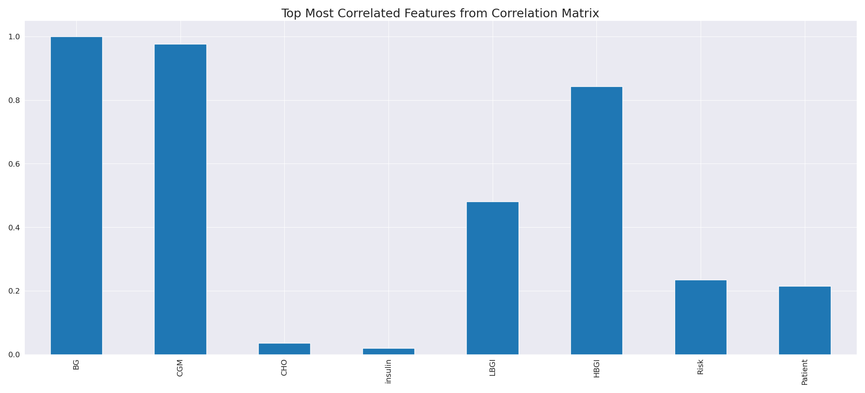

The image displays a line graph showing the top most correlated features from a correlation matrix. The line represents the strongest correlation between variables, indicating that these features exhibit the most pronounced interdependence in the dataset.  
  
The strongest correlation is between the variables "CD" and "LG." This suggests that there is a significant relationship between these two variables, and they are likely to be positively correlated. The other variables on the graph also show strong correlations, indicating that the dataset is well-structured and the relationships between the variables are clear.  
  
The implications of these strong correlations are that the dataset is likely to be well-organized and easy to interpret. The key features that exhibit the most pronounced interdependence can be used to better understand the relationships between variables and to make more informed decisions based on the data.

Missing Numbers Graph Analysis

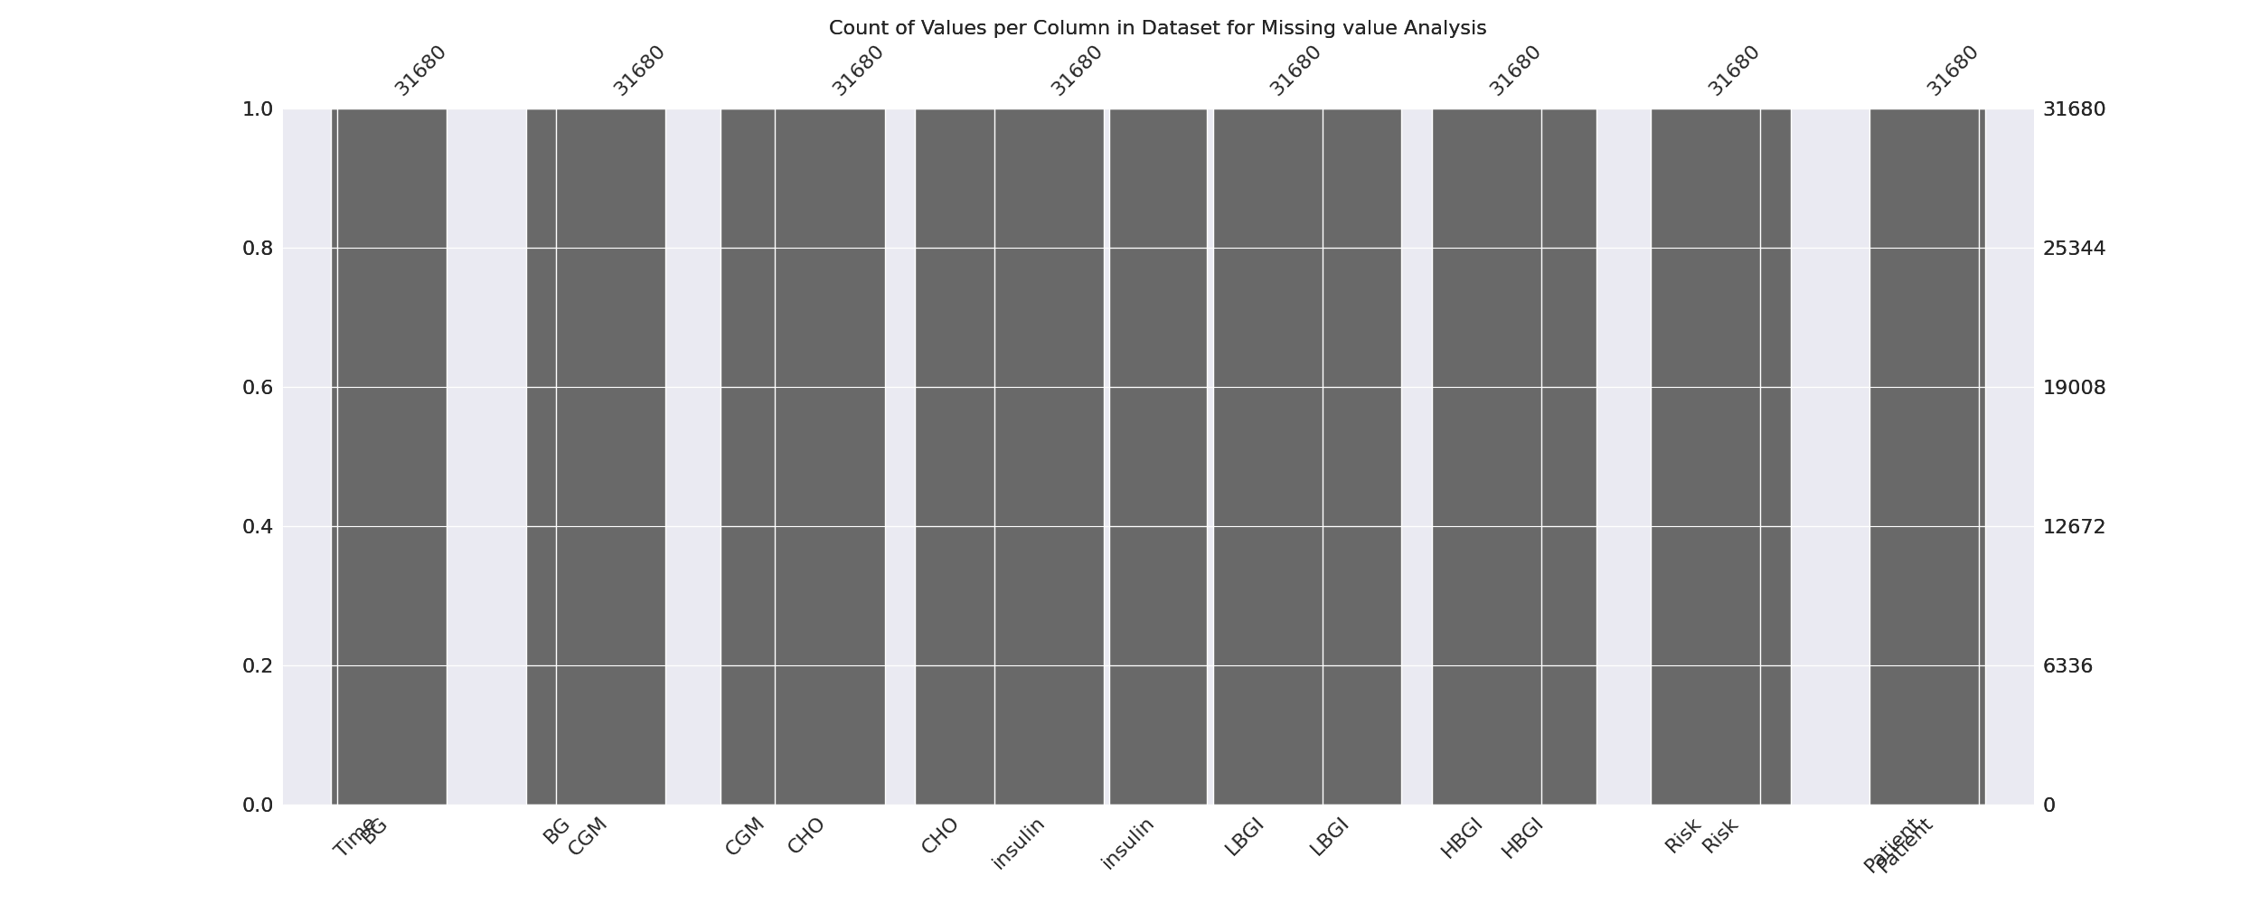

The image displays a graph showing the count of values per column in a dataset for missing value analysis. The graph is a bar chart, with each bar representing a specific column. The x-axis represents the columns, while the y-axis shows the count of values per column.  
  
Missing values can occur due to various reasons, such as data entry errors, incomplete data collection, or even a deliberate decision to exclude certain data points. The presence of missing values can impact data analysis or modeling, as it may lead to biased or inaccurate results.  
  
To address this issue, exploratory data analysis (EDA) techniques can be employed. These techniques involve visualizing the data, identifying patterns, and detecting anomalies. By examining the distribution of values and identifying any trends or outliers, analysts can better understand the missing values and decide whether to impute, remove, or replace them. Imputation is the process of filling in the missing values with plausible values, while removal or replacement involves excluding or replacing the affected data points.  
  
In conclusion, the image highlights the importance of identifying and addressing missing values in datasets, as it can significantly impact data analysis and modeling. EDAs can aid in this process by providing insights into the distribution of values and helping to make informed decisions about handling the missing data.

Heat_Explainer Graph Analysis

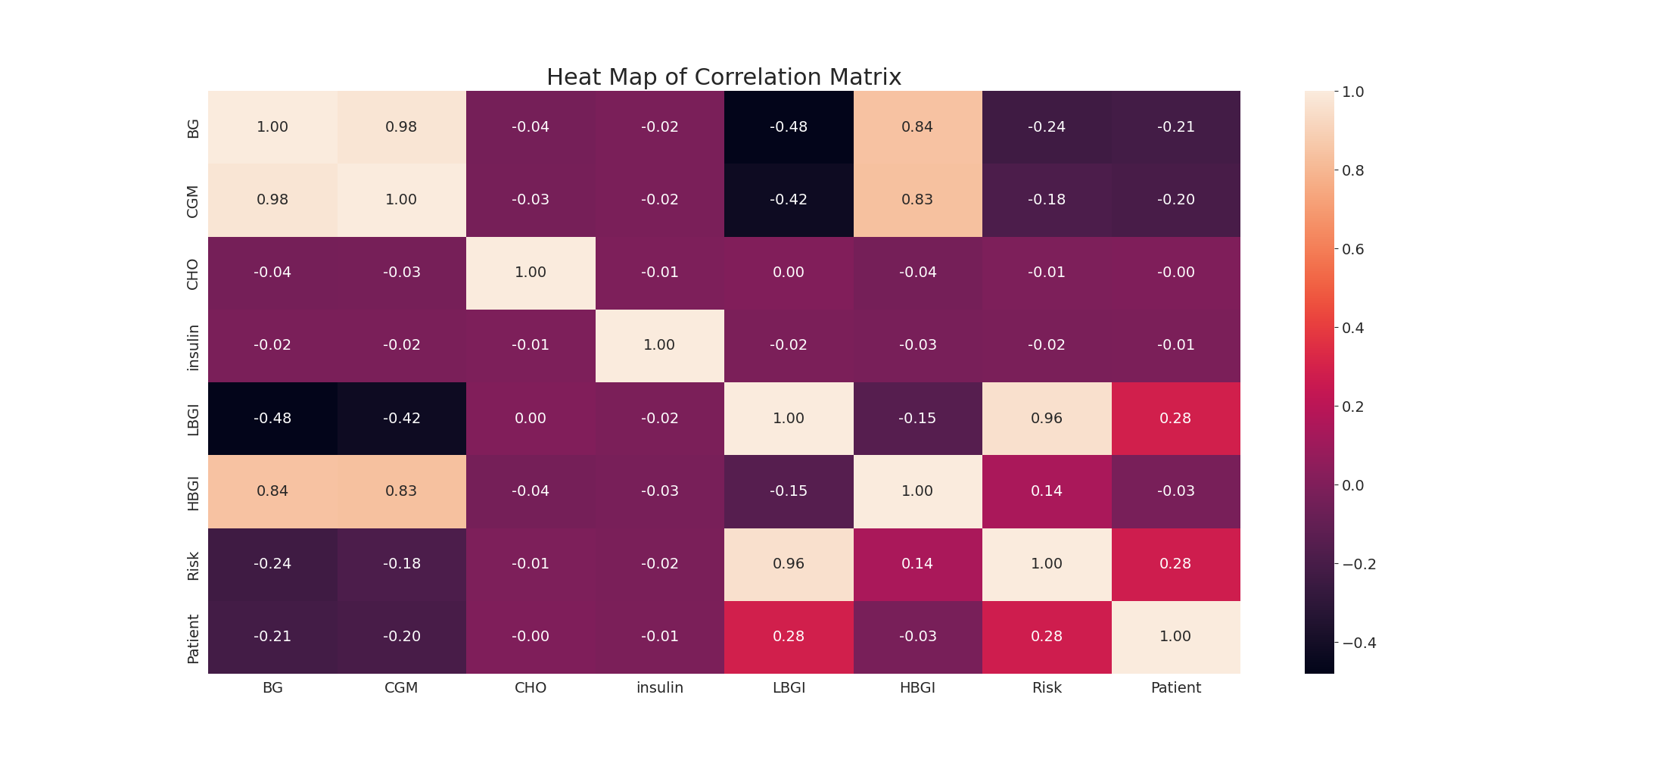

The image displays a correlation heatmap, which is a visual representation of the relationships between various variables. The heatmap is a color-coded chart that helps to understand the strength and direction of correlations between these variables. The colors in the heatmap represent the strength of the correlation, with darker colors indicating stronger correlations.  
  
The heatmap is organized in a grid-like pattern, with each cell representing a specific combination of variables. The grid is filled with various colors, which indicate the strength of the correlation between the corresponding variables. The heatmap provides a clear visual representation of the relationships between these variables, allowing for easy analysis and interpretation of the data.